EXPT NO:4 | TRANSFORM DATA TO SUIT BI REPORTING REQUIREMENTS AND  DESIGN A DASHBOARD WITH KEY PERFORMANCE INDICATORS (KPIs ) USING TABLEAU AND POWERBI
DATE: 24.07.2026

Github link:
https://github.com/Mithunjai/Bussiness-Intelligence

PRE-LAB QUESTIONS (PROVIDE BRIEF ANSWERS TO THE FOLLOWING QUESTIONS)
IN-LAB EXERCISE:

1. What is the role of data transformation in BI reporting?
Answer:
Data transformation is the process of converting raw data into a structured and usable format for analysis. It involves cleaning, filtering, merging, and reshaping data from different sources. This process ensures that the data is accurate, consistent, and ready for reporting. Data transformation also helps remove errors and duplicate records that may affect analysis. It improves the quality of business insights by organizing data into meaningful formats. As a result, BI reports become more reliable, efficient, and easier for decision-makers to understand.

2. What are the common data cleaning techniques in Tableau and Power BI?
Answer:
Tableau and Power BI provide several tools for cleaning data before analysis. Common techniques include removing duplicate records, handling missing values, and correcting inconsistent data formats. Users can rename columns, change data types, split or merge columns, and filter unwanted rows. Both tools also allow replacing incorrect values and trimming extra spaces from text fields. Power BI mainly uses Power Query Editor, while Tableau offers the Data Interpreter and data preparation features. These techniques improve data accuracy and ensure reliable visualizations.

3. How do Tableau and Power BI handle data aggregation?
Answer:
Data aggregation is the process of summarizing detailed data into meaningful values such as totals, averages, or counts. Tableau and Power BI automatically aggregate numerical data when creating visualizations. Users can choose different aggregation functions like SUM, COUNT, AVERAGE, MIN, and MAX based on their analysis needs. Both tools allow changing the aggregation level at any time. They also support grouping and hierarchical analysis for deeper insights. This feature helps users quickly understand trends and compare business performance.

4. What are KPIs, and why are they important in a dashboard?
Answer:
Key Performance Indicators (KPIs) are measurable values used to evaluate how effectively an organization achieves its goals. They provide a quick overview of business performance using important metrics such as sales, profit, customer satisfaction, or revenue growth. KPIs help managers monitor progress and identify areas that require improvement. In dashboards, they are displayed using cards, gauges, or charts for easy interpretation. They support faster decision-making by presenting critical information at a glance. Well-designed KPIs improve business monitoring and strategic planning.

5. What are the different types of charts available in Tableau and Power BI for visualization?
Answer:
Tableau and Power BI offer a wide range of charts to visualize data effectively. Common chart types include bar charts, column charts, line charts, pie charts, and area charts. They also support scatter plots, maps, tree maps, waterfall charts, and heat maps for advanced analysis. Tables, matrices, and KPI cards are used to display detailed business information. Users can also create interactive dashboards with filters and drill-down features. Choosing the right chart type makes data easier to understand and improves decision-making.

OBJECTIVE:
To transform COVID-19 data into a structured format suitable for Business Intelligence (BI) reporting and design interactive dashboards with Key Performance Indicators (KPIs) using Tableau and Power BI.
PROCEDURE:
- Data Collection:
  - Import the COVID-19 dataset from inbuilt sources like Our World in Data or CSV files containing country-level COVID statistics (e.g., new cases, deaths, vaccinations).
  - Datasets may include fields such as date, location, new_cases, total_cases, new_deaths, total_deaths, people_vaccinated, etc.
- Data Cleaning and Transformation:
  - Convert columns like date to proper date formats.
  - Handle missing or null values in new_cases, total_cases, etc.
  - Create calculated fields (e.g., daily case growth rate, case fatality rate, vaccination percentage).
- Data Aggregation:
  - Aggregate data by continent, country, or month.
  - Use measures like SUM(new_cases), AVG(positivity_rate), MAX(total_deaths).
- Designing KPIs:
  - Identify KPIs such as:
    - Total Confirmed Cases o Total Deaths o Case Fatality Rate o Vaccination Coverage (%)
    - Daily Case Growth Rate
  - Use DAX (Power BI) or Calculated Fields (Tableau) to compute and visualize these KPIs.
- Dashboard Development:
  - Build visualizations such as:
    - Line charts for daily new cases and deaths o Bar charts for country-wise vaccination progress o Maps to show regional case distribution
    - KPI cards for high-level insights
  - Use filters (e.g., by continent, country) and slicers (e.g., by date range) for interactivity.
- Publishing and Sharing:
  - Publish the dashboard using Tableau Public/Server or Power BI Service.
  - Share the dashboards with stakeholders through public or organizational portals.
Experiment Dataset: COVID-19 Global Dataset
Fields Used:
  - Date – Date of the report
  - Location – Country or region
  - New Cases – Daily reported cases
  - New Deaths – Daily reported deaths
  - People Vaccinated – Cumulative vaccinated count
  - Total Cases – Cumulative confirmed cases
  - Total Deaths – Cumulative deaths
  - Population – Total population of the country

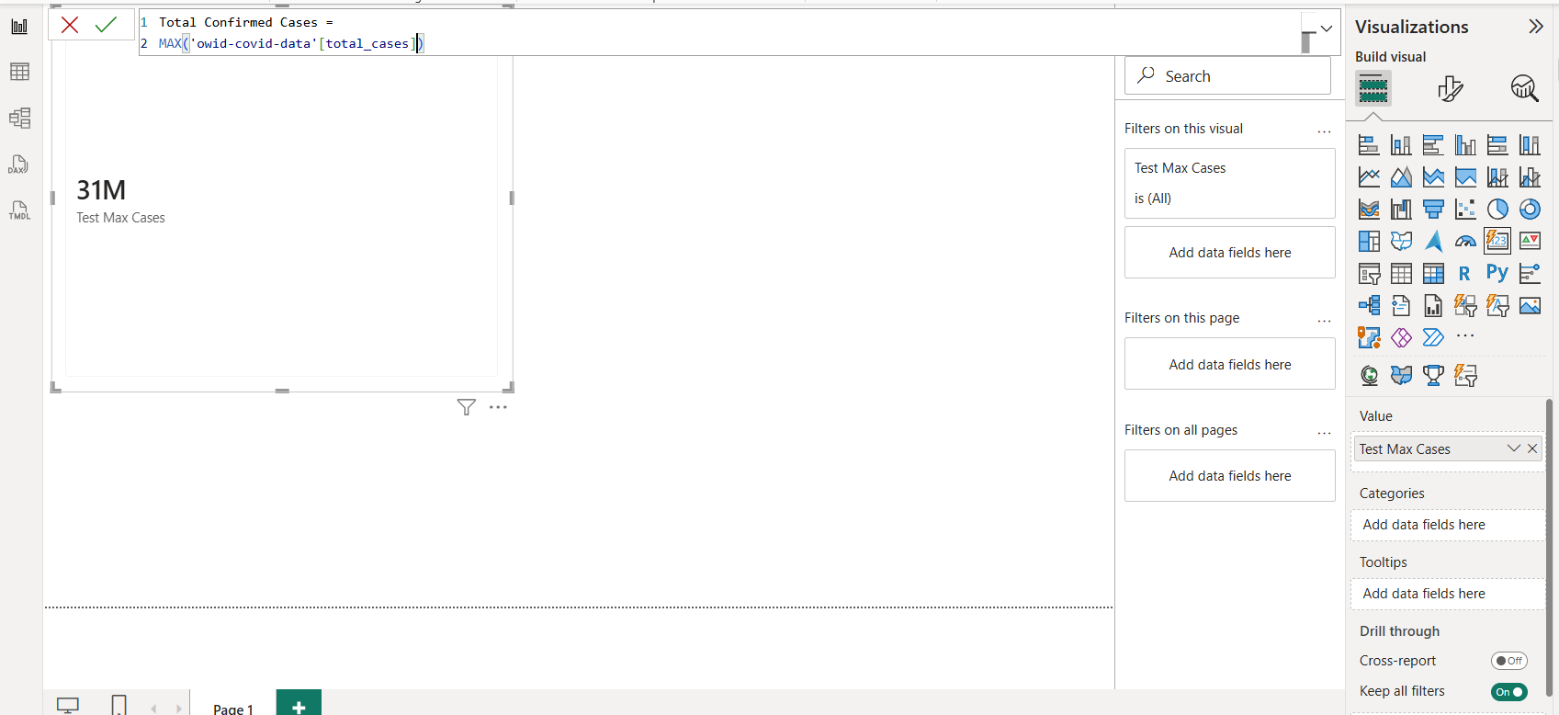

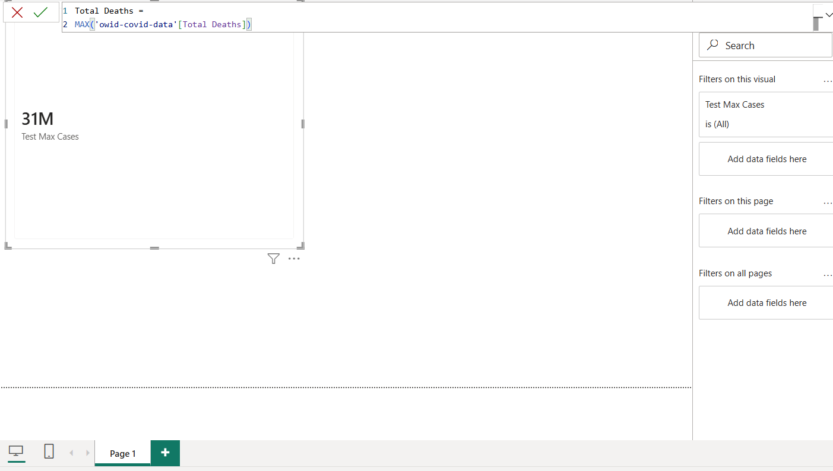

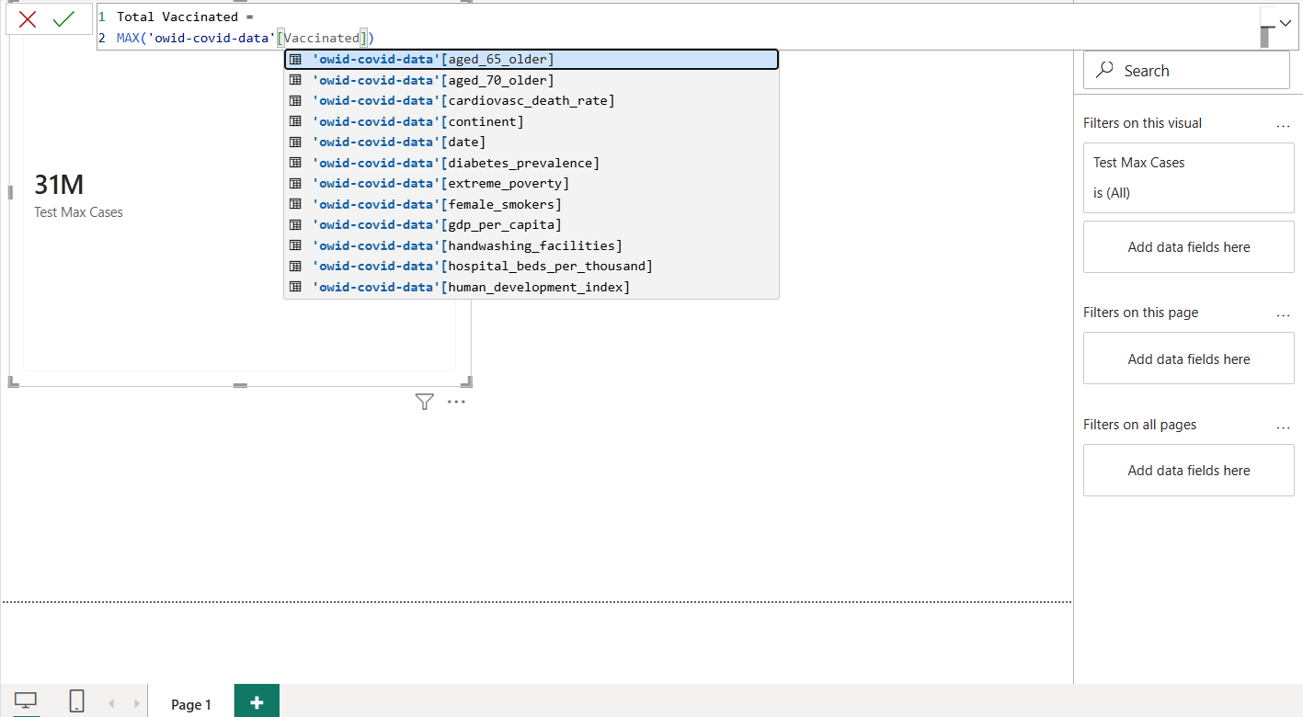

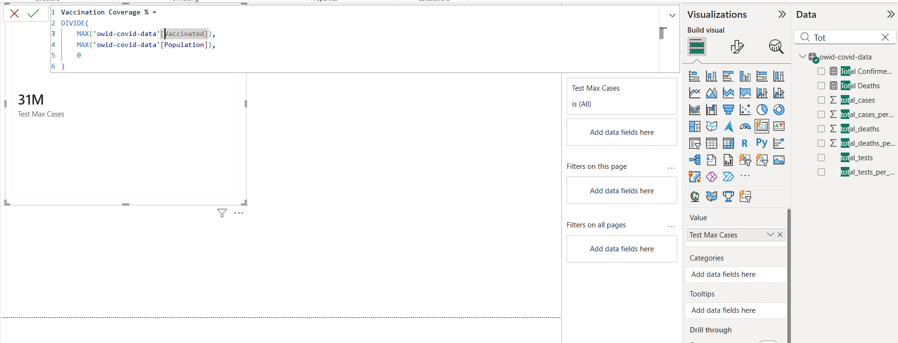

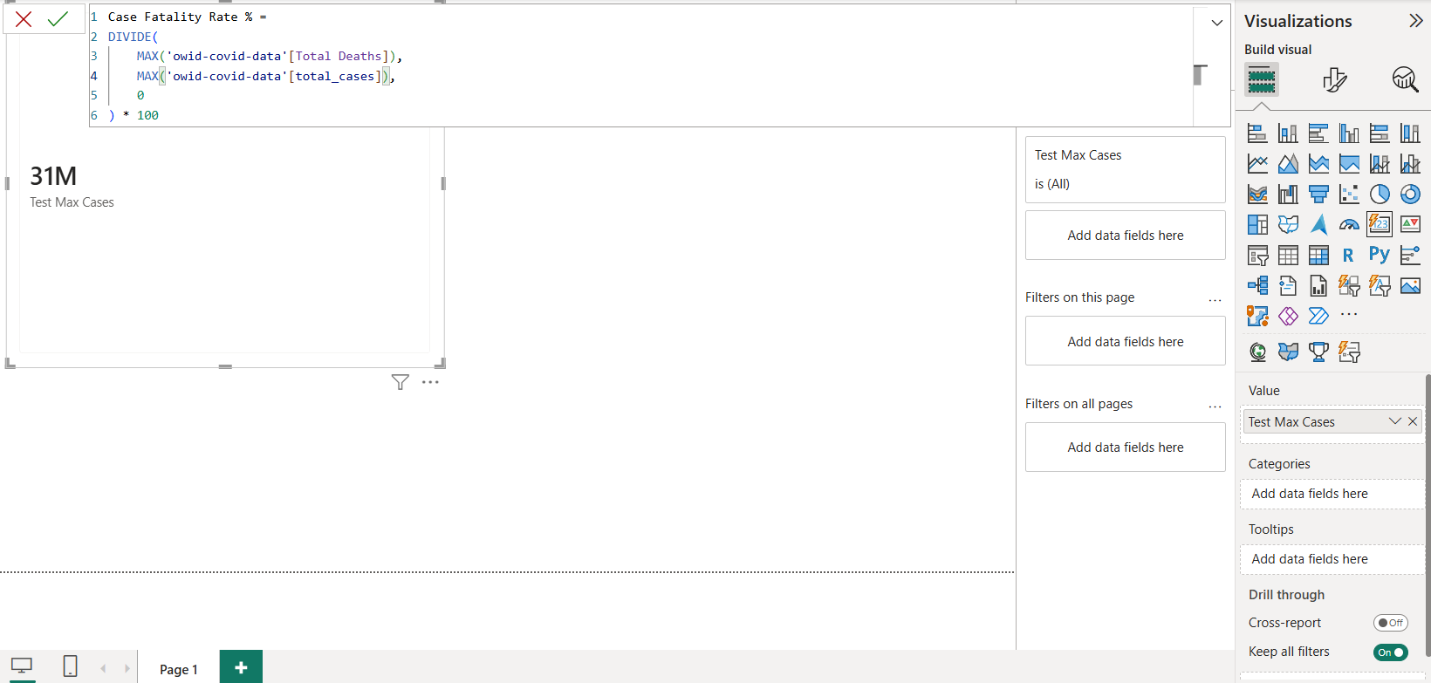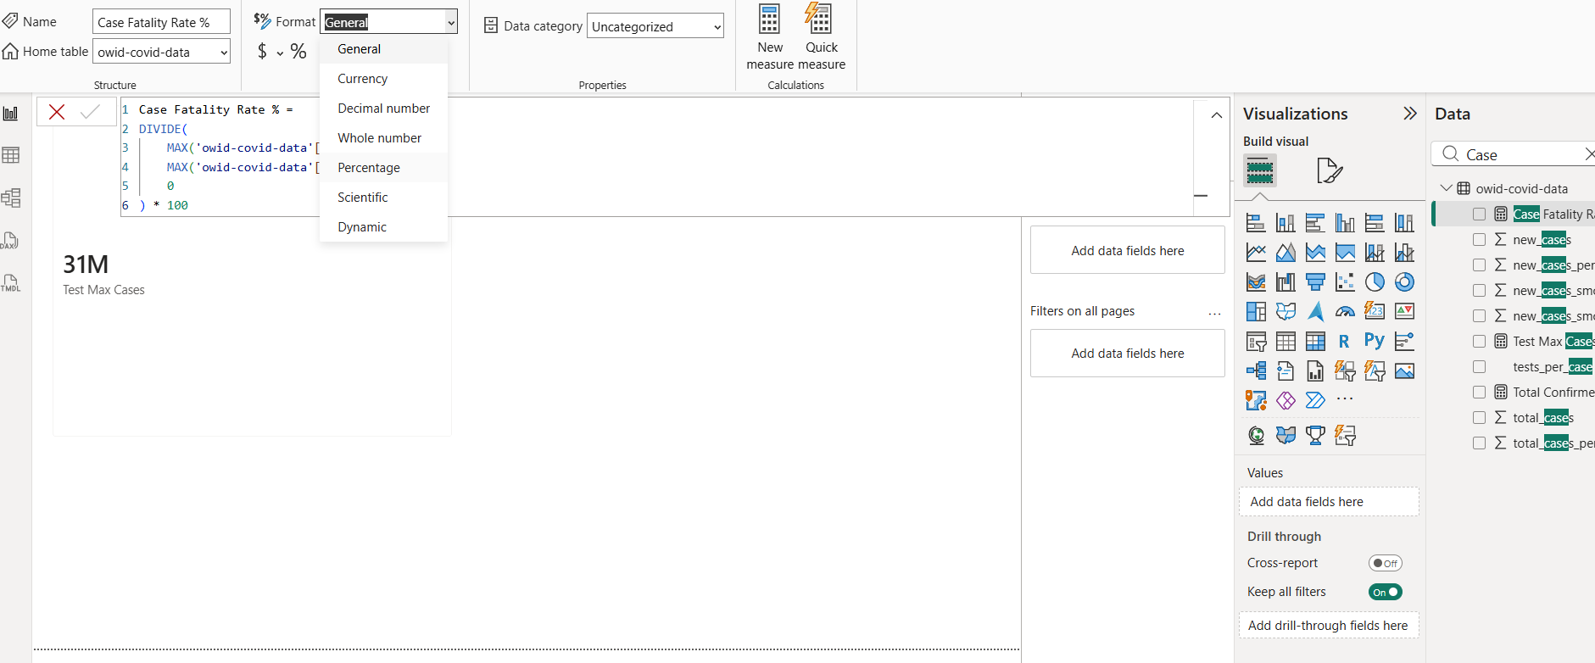

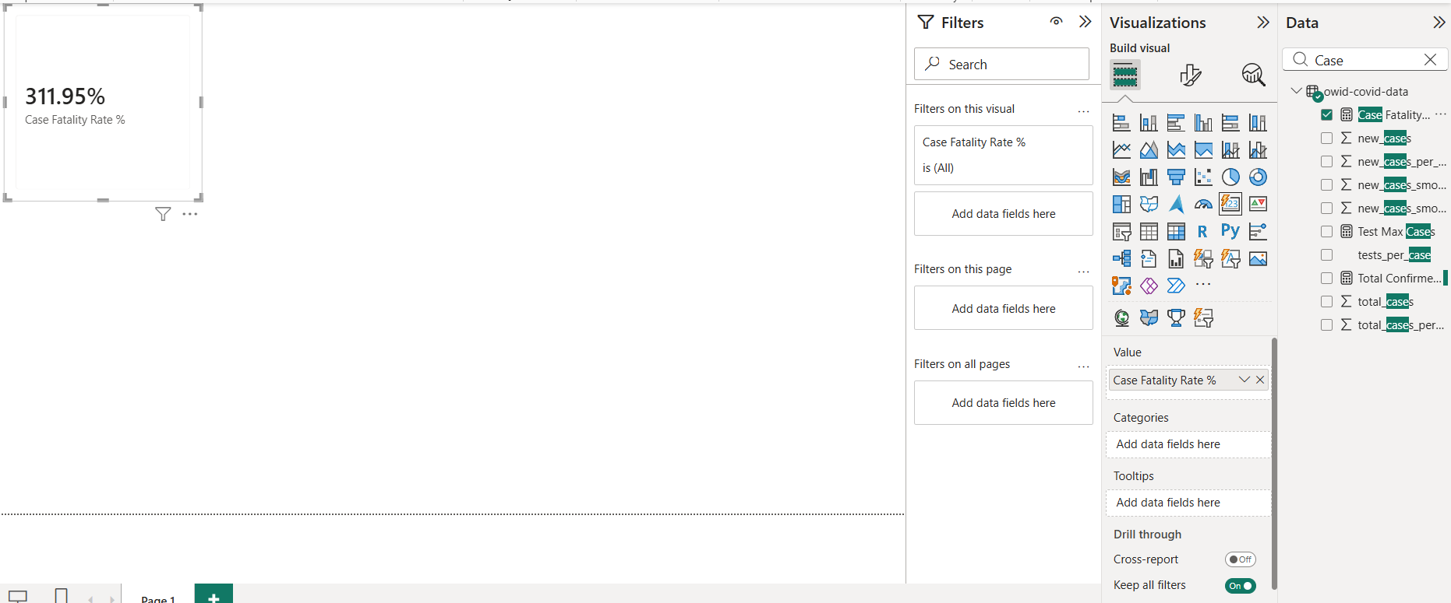

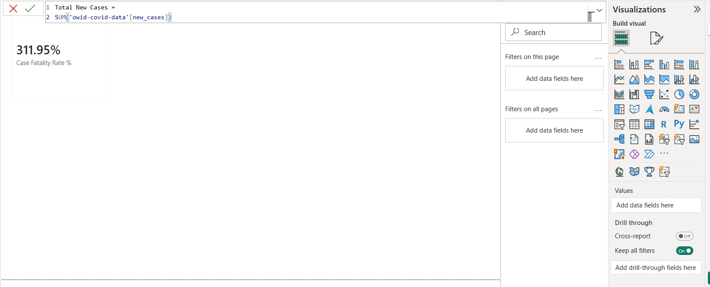

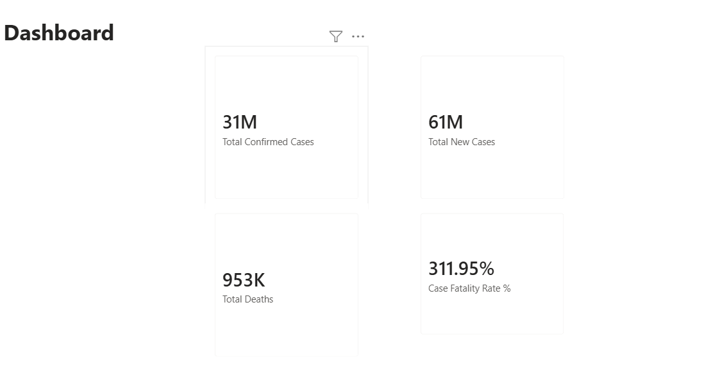

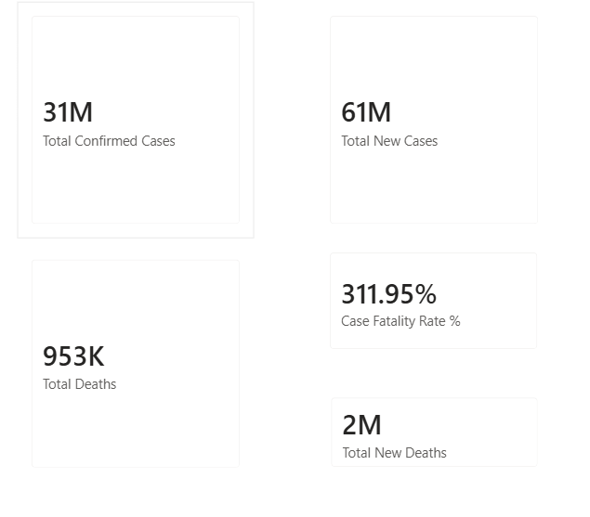

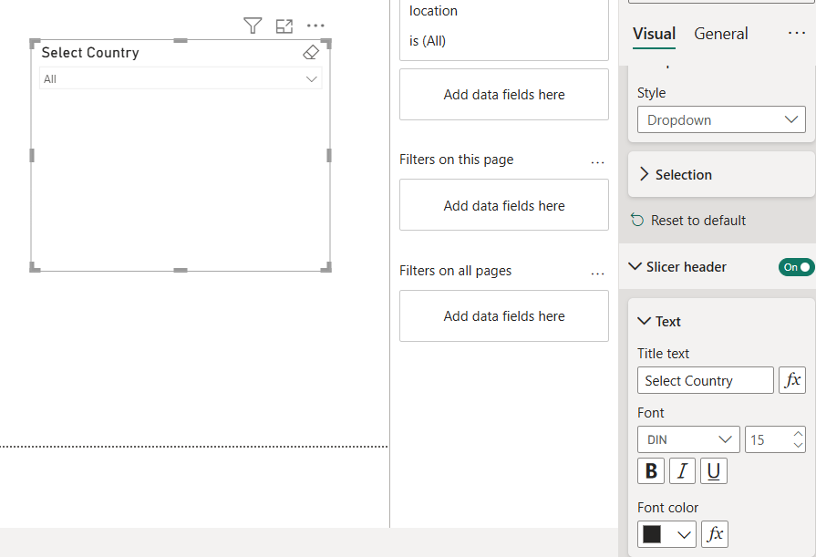

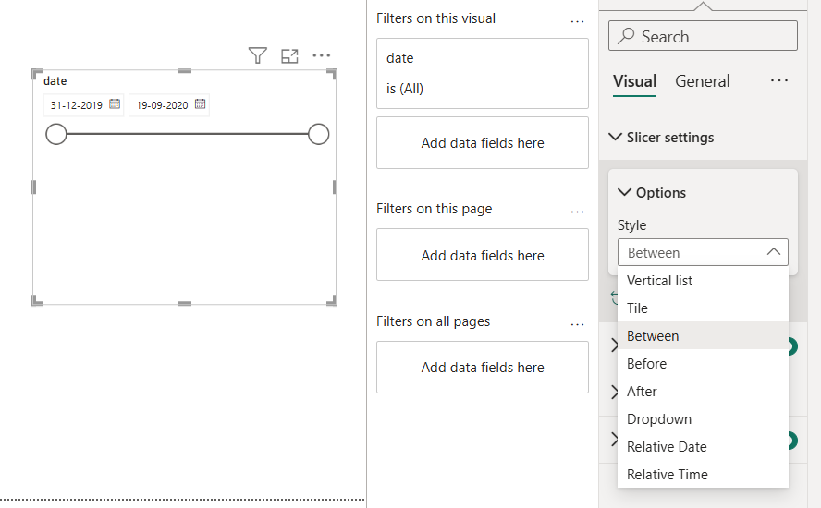

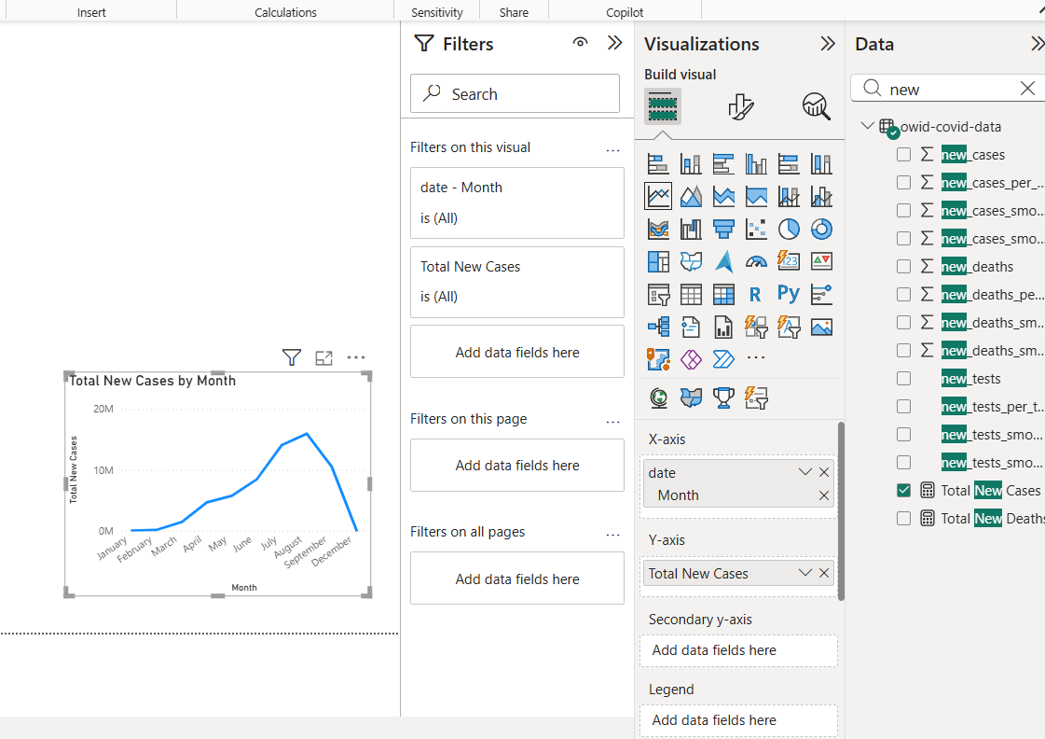

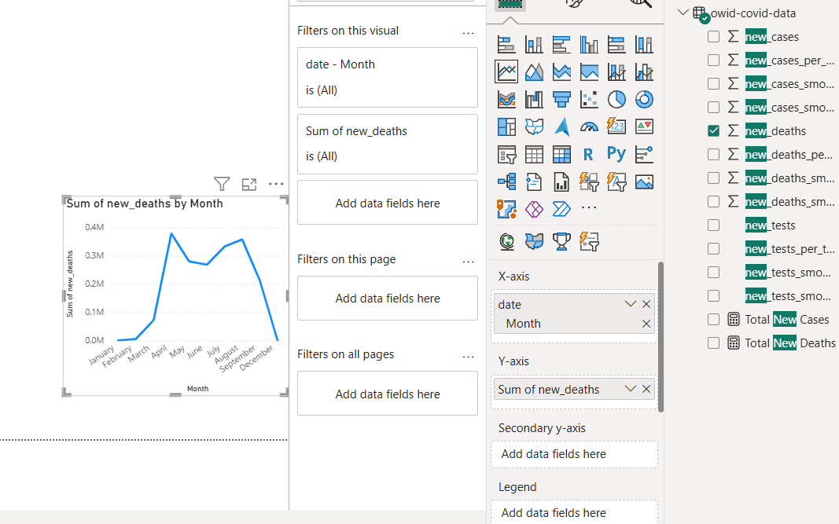

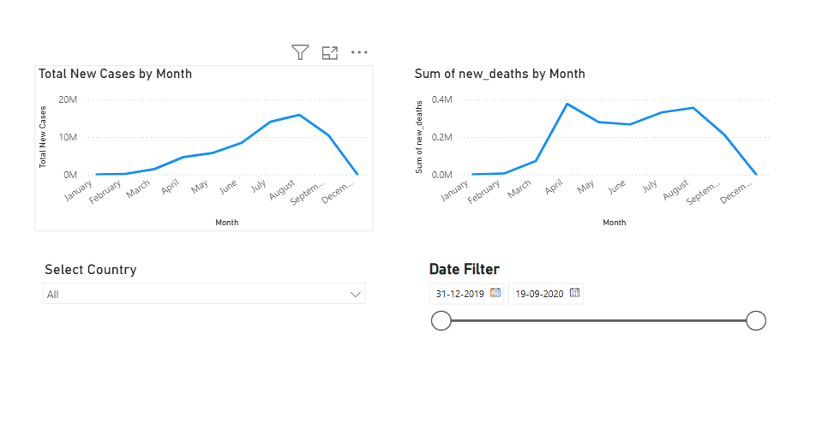

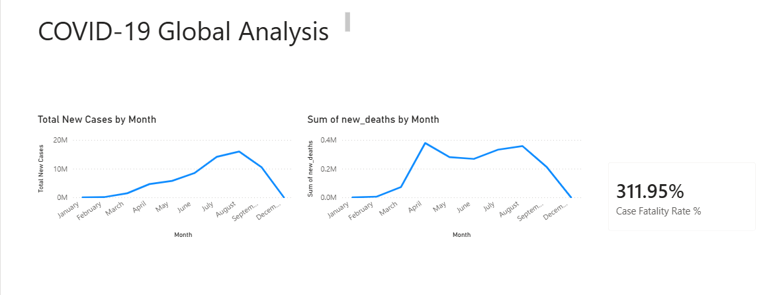

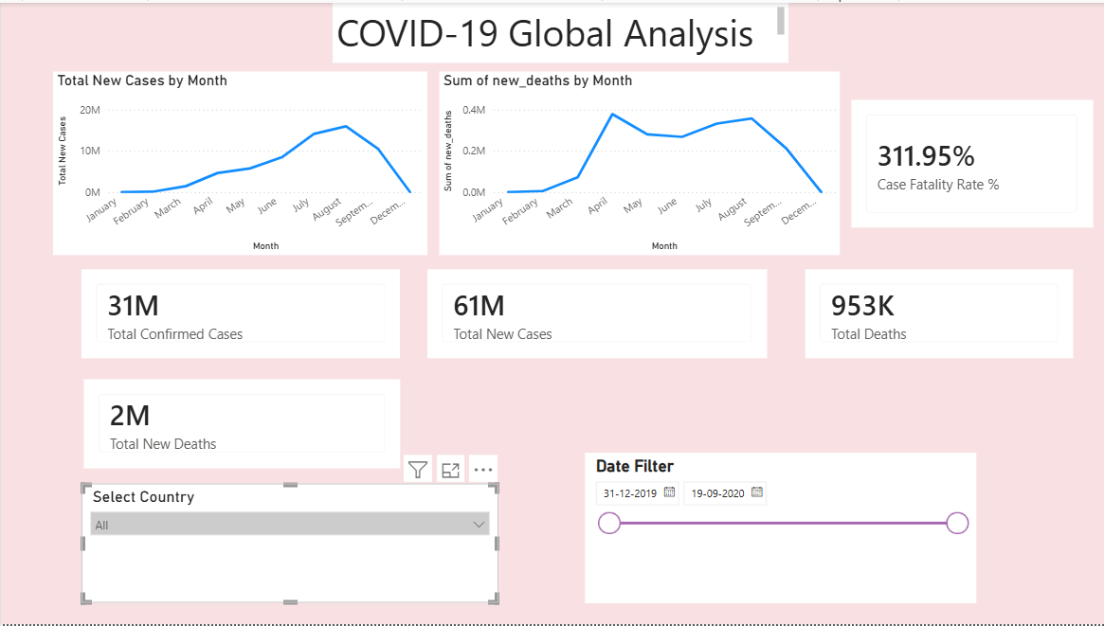

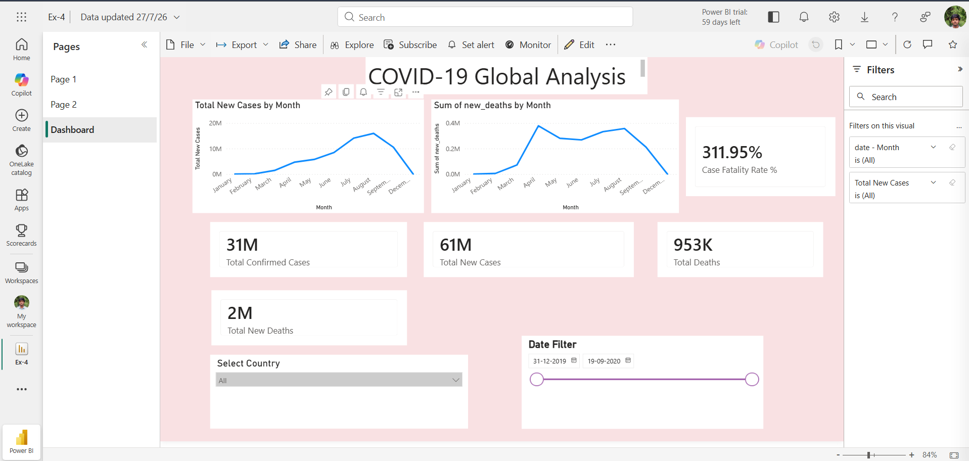

PowerBI link:
https://app.powerbi.com/links/jg6GZR8eN-?ctid=6b8b8296-bdff-4ad8-93ad-84bcbf3842f5&pbi_source=linkShare

Tableau:
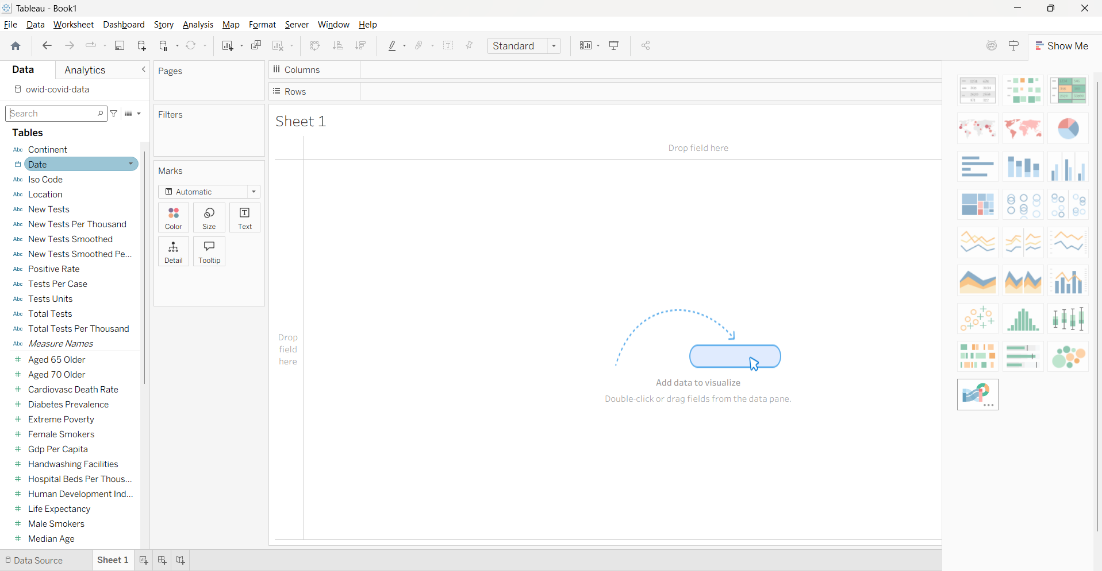

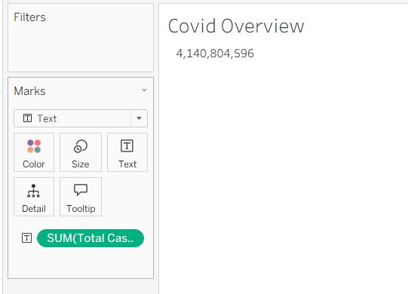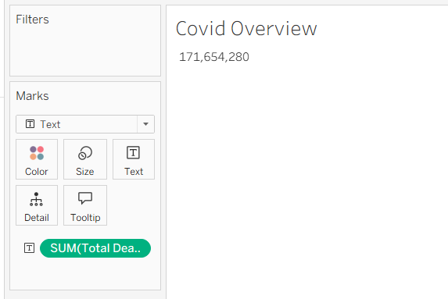

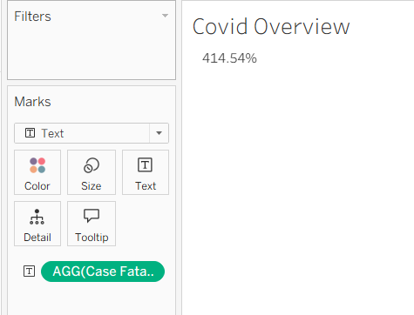

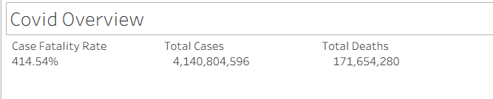

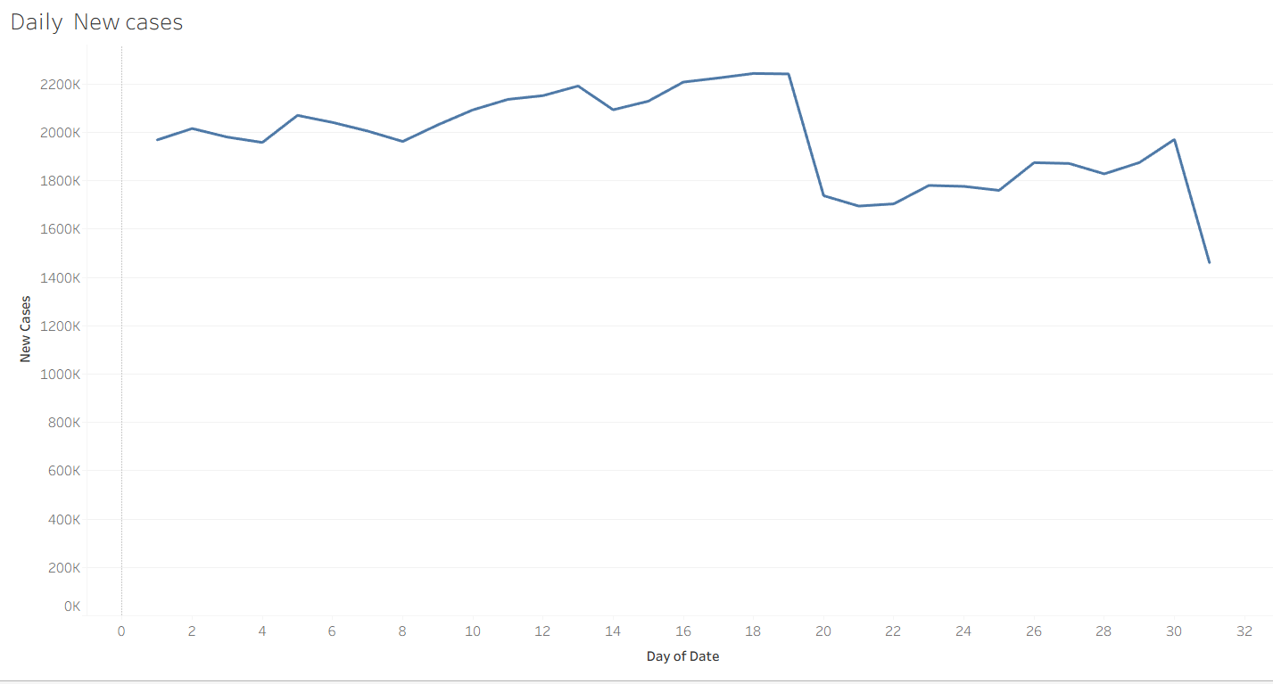

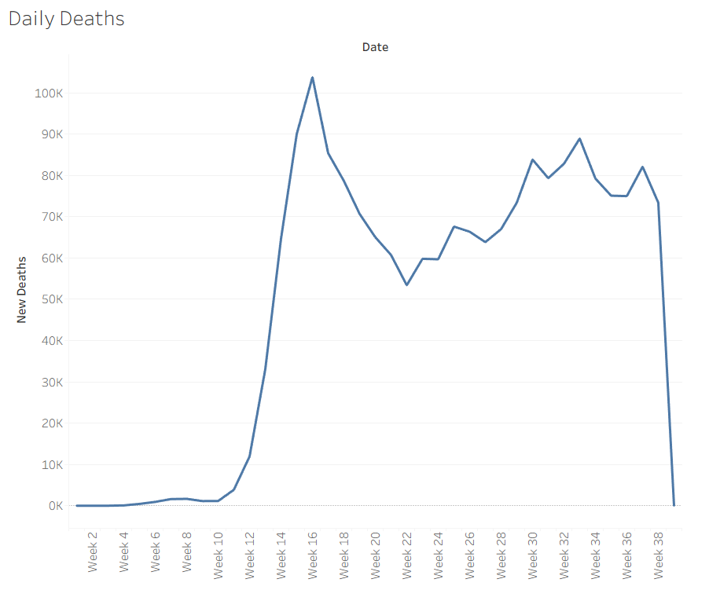

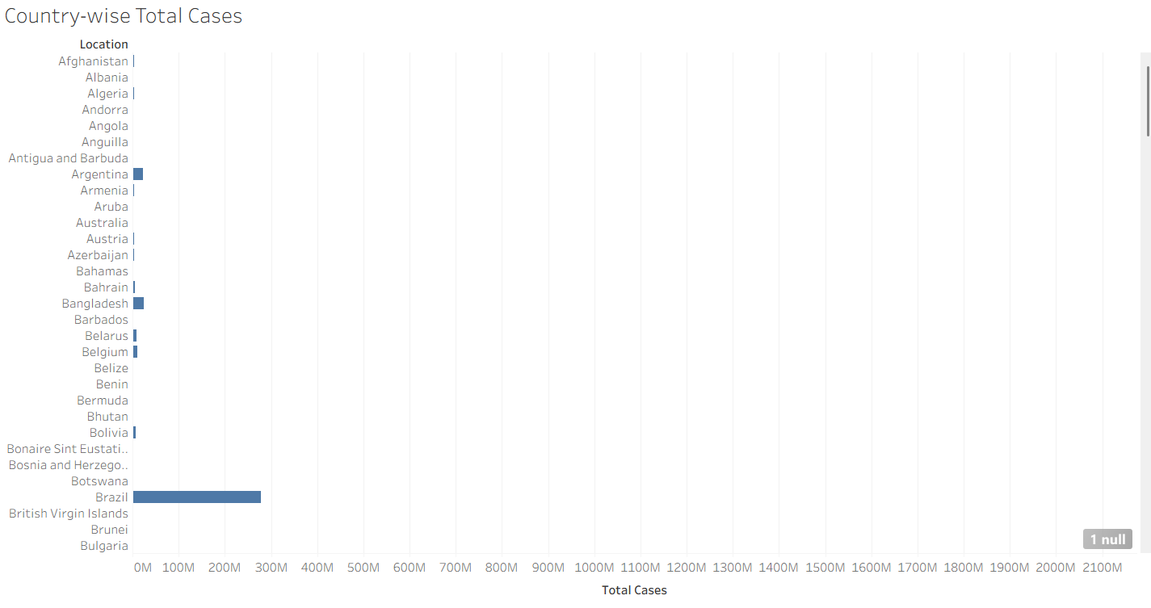

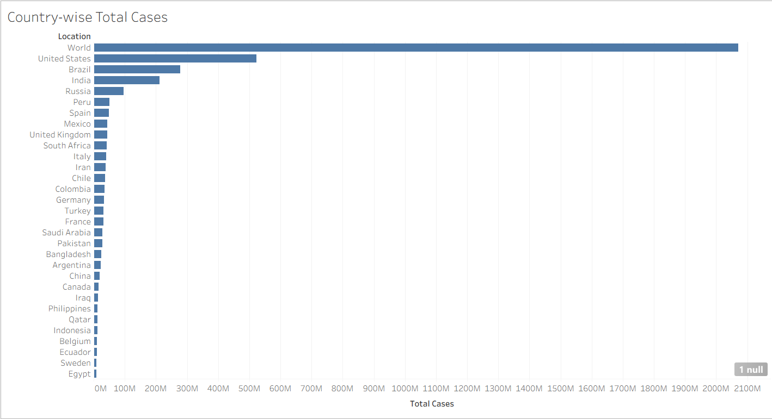

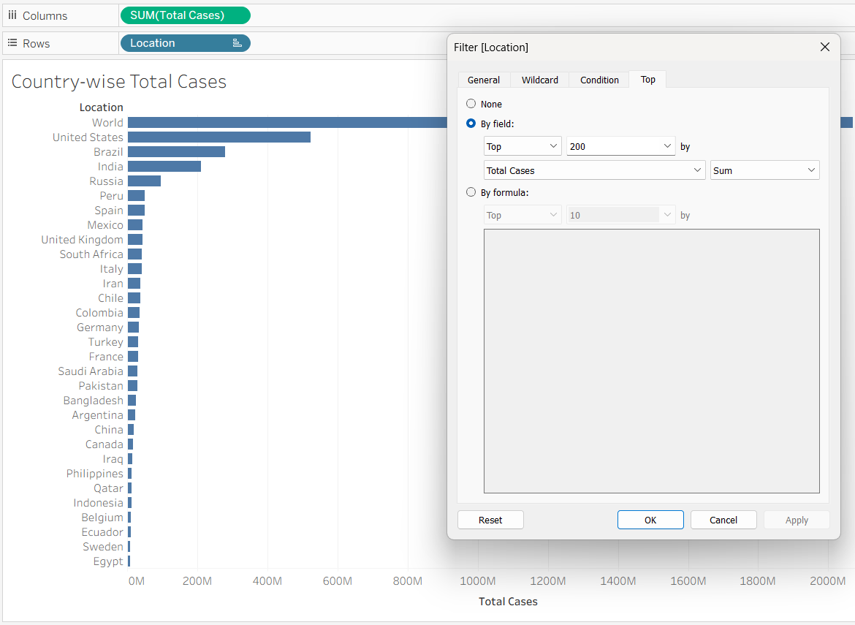

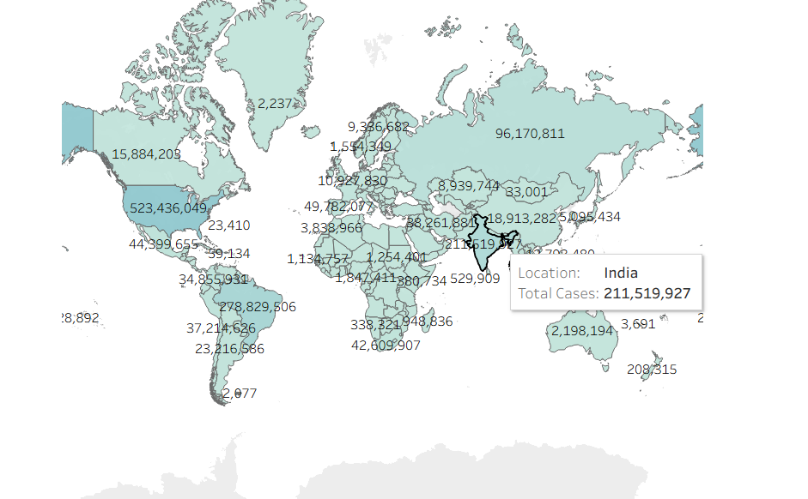

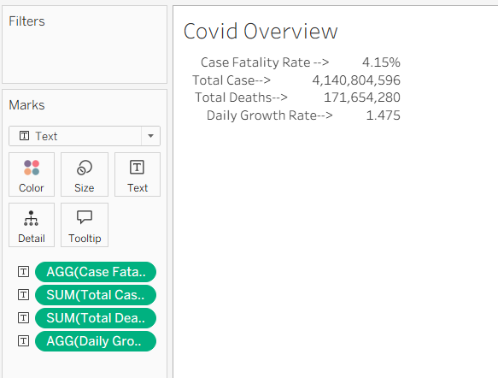

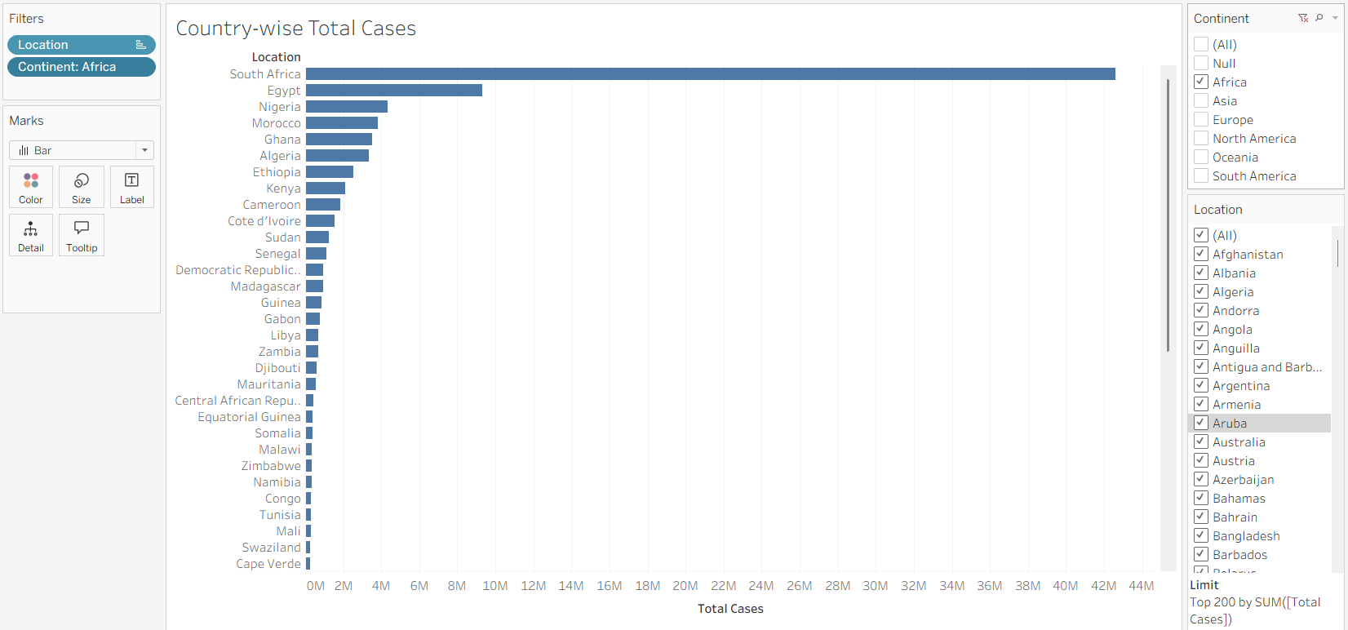

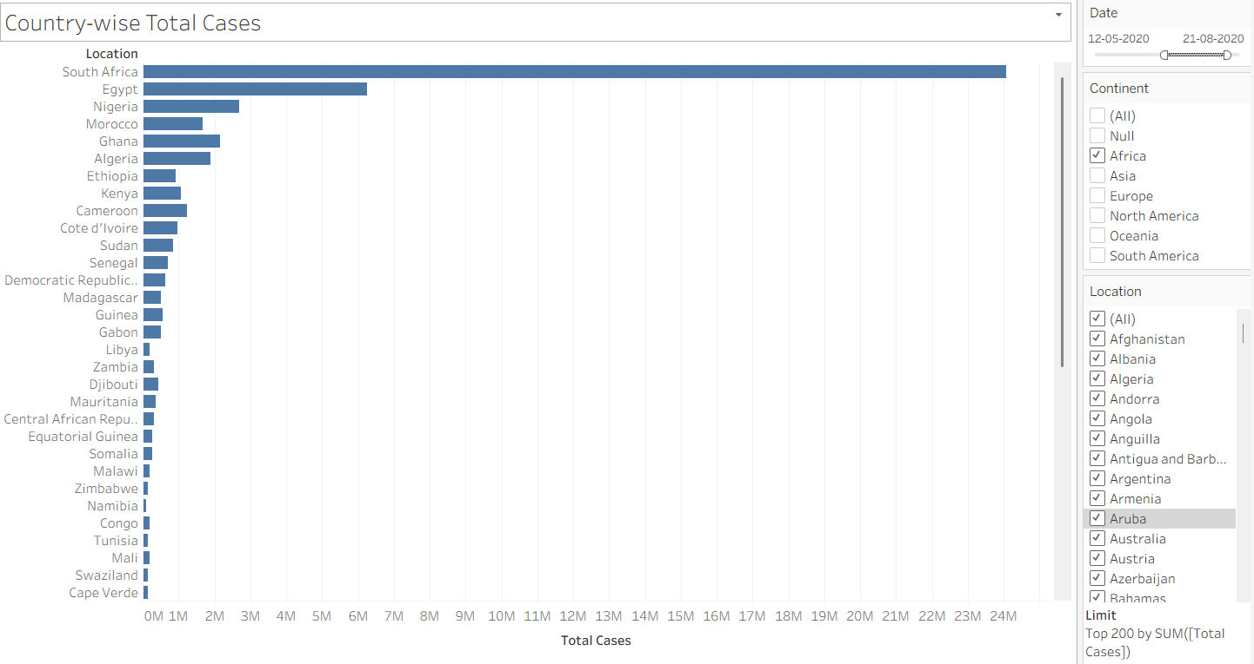

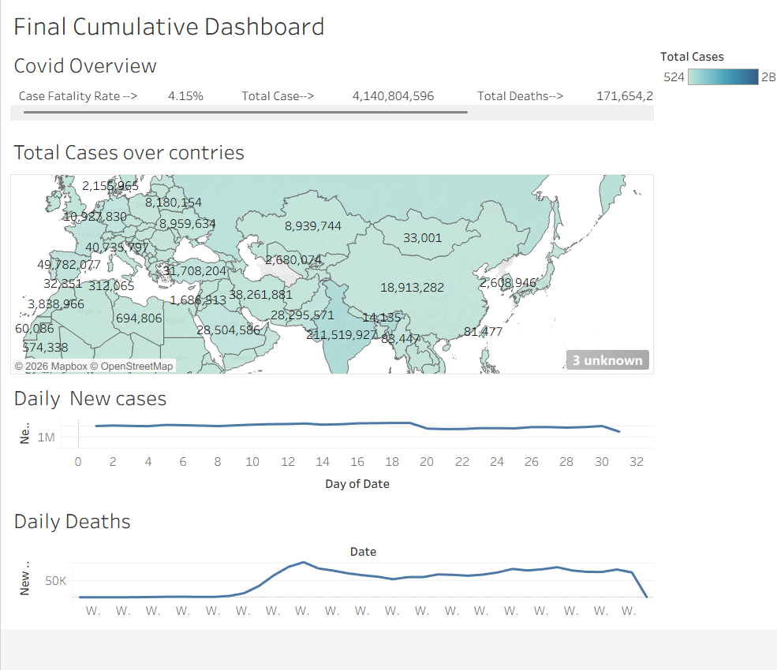

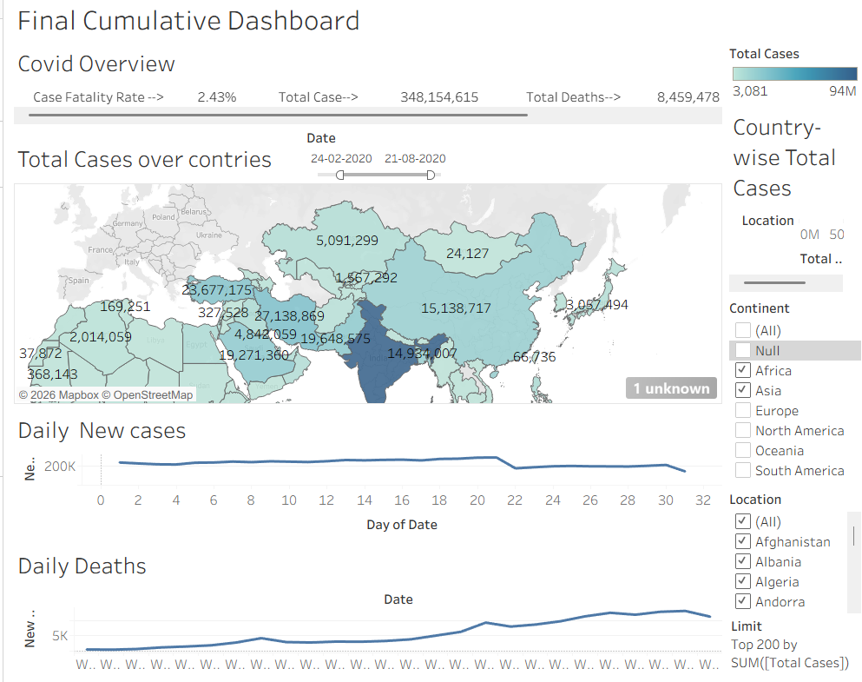

POST-LAB QUESTIONS (PROVIDE BRIEF ANSWERS TO THE FOLLOWING QUESTIONS)
- How did data transformation improve the quality of insights in your COVID-19 dashboard?
Answer:
Data transformation improved the quality of insights by converting raw COVID-19 data into a structured and meaningful format suitable for analysis. It helped in cleaning missing values, converting dates into proper formats, creating calculated fields such as Case Fatality Rate and Vaccination Coverage, and aggregating data by country and time period. These transformations made the dashboard more accurate, easier to understand, and helped users identify trends and patterns effectively.

- What challenges did you encounter during the data cleaning process, and how did you resolve them?
Answer:
During the data cleaning process, challenges such as missing values, inconsistent date formats, and incomplete records were encountered. These issues were resolved by converting date fields into proper formats, replacing or removing null values where necessary, checking for duplicate records, and ensuring that numerical fields such as cases, deaths, and vaccinations were correctly formatted. This improved the reliability and accuracy of the dashboard.

- Which KPI provided the most valuable insight, and why?
Answer:
The Case Fatality Rate (CFR) KPI provided one of the most valuable insights because it showed the percentage of confirmed COVID-19 cases that resulted in deaths. It helped in understanding the severity and impact of the pandemic across different regions. Other KPIs such as total cases, total deaths, and vaccination coverage also provided important information for monitoring the spread and control of COVID-19.

- How does interactivity in dashboards improve user experience?
Answer:
Interactivity improves user experience by allowing users to explore data according to their requirements. Features such as filters, slicers, date ranges, and map interactions allow users to analyze COVID-19 trends for specific countries, continents, or time periods. This makes the dashboard more flexible, user-friendly, and helps users gain faster and more meaningful insights.

- What steps would you take to further enhance the dashboard’s effectiveness?
Answer:
To further enhance the dashboard’s effectiveness, additional features such as advanced filters, predictive analysis, real-time data updates, and more detailed visualizations can be added. Improving the dashboard design with better color schemes, clear labels, and interactive elements can also make it easier for users to understand the insights. Integration with updated data sources would help maintain accuracy and relevance.

RESULT:

The COVID-19 dataset was successfully cleaned, aggregated, and transformed for visual analysis using Tableau and Power BI. Missing values, data type mismatches, and inconsistencies were addressed. KPIs such as vaccination rate and daily case growth offered valuable insights into the pandemic trends across countries and timeframes. The resulting interactive dashboards allowed for effective public health monitoring and communication.

ASSESSMENT

Description |  | Max Marks | Marks Awarded
Pre Lab Exercise |  | 5
In Lab Exercise |  | 10
Post Lab Exercise |  | 5
Viva |  | 10
 | Total | 30
 | Faculty Signature

